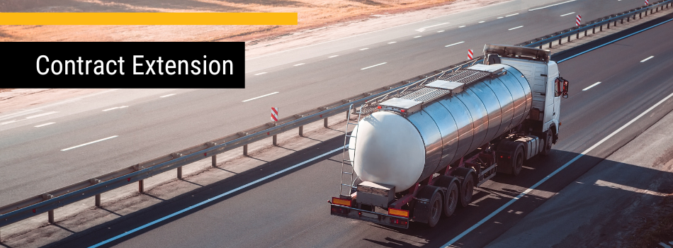

2403/0109 Bulk Fuels

Dear Procurement Australia member

Please note that the first and last extension of the above mentioned contract has been exercised fully. It takes effect from 1 April 2024 and will expire on 31 March 2025.

The list of continuing Suppliers by category and states serviced is as follows:

Supplier |  | Category 1 – Bulk Fuels | Category 2 – Bulk Metered Deliveries
1 | Ampol Australia Petroleum Pty Ltd | NATIONAL | NATIONAL
2 | Petrogas Pty Ltd | NSW and VIC | NSW and VIC
3 | Pacific Petroleum Pty Ltd | ACT, NSW, QLD, SA, and VIC

For more information, please contact your Relationship Manager.

